Version Control Software Evaluation Report
Math for Games
Kari Dunn
20/5/21
Version Control Software:
The version control software used was: git
The client program was: GitKraken

Performance:
GitKraken is easy to use since it has an intuitive graphical user interface allowing you to quickly commit and push and stage your work with out interrupting the daily workflow. GitKraken also provides most of the the information that you need readily. There are some features that are not available on GitKraken such as comparing changes between two commits like you would be able to do in the command line. Overall the performance was very good and pretty much does everything you would need to do for a project like the maths for games assignment.
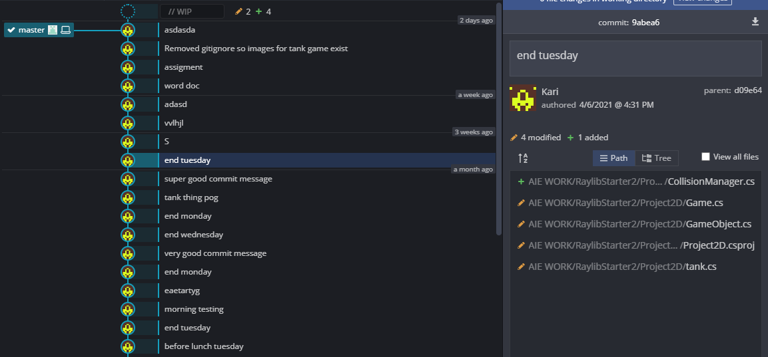
Figure 1: GitKraken commit history

Evaluation:
GitKraken would be useful in a professional game development environment for organisation because it can speed up the version control work flow. It shouldn't be used as the sole version control software because it is easy to make mistakes and does not have the full functionality of git so it should be used along side another software like the command line.

Environmental Considerations:
The project is hosted on github and because of the version control software all changes that are committed are stored on the server. By storing the changes that happen you can combine them to go back to any committed state that the project was in. This makes the size the project takes up many times larger than it actually is. Usually code doesn't take up that much space since it is just text but a github repository can grow to several gigabytes in size. Storing a gigabyte on a server costs about 3.1 kWh per gigabyte according to the American Council for an Energy-Efficient Economy which is about 600, 000 times more energy than it takes to store a gigabyte on a personal hard drive. This means that storing your version control repositories results in a yearly carbon footprint of about 2 grams of C02 for every megabyte.

